Processing of Patient Personal Data: A Guideline for General Practitioners

File name: GP_GDPR_Appendices_v2.3.pdf
Date: 29/08/2019,
Version: 2.3
Governance: Irish College of General Practitioners (ICGP)
Authors: ICGP Data Protection Working Group

This is Part 3, Appendices, of the ICGP Guideline document on Data Protection. The full document is available to download.

Disclaimer
The information contained in this document is for general guidance only and cannot be relied upon as legal advice. The ICGP accepts no liability for the accuracy of the information contained in this document and you should always obtain specific legal advice separately before taking any action based on the information provided herein or if you are unsure as to how to act in any situation.

Table of Contents
Processing of Patient Personal Data: A Guideline for General Practitioners 1
Disclaimer 1
Table of Contents 1
Appendix A: Data Protection Check List 2
Appendix B: Sample Request for Transfer of GP Records 3
Appendix C: Request form for Access to Medical Records 4
Appendix D: Waiting Room Notice 5
Appendix E: Practice Privacy Statement 6
Appendix F: Data Protection Accountability Log 10
Appendix G: Medical Student Confidentiality Agreement 12
Appendix H: Staff Confidentiality Agreement 13
Appendix I: Template for Records of Processing Activity 14
Appendix J: Protocol for Managing Patient Record Access Request 16
Appendix K: Protocol for Managing a Data Breach 17
Appendix L: Data Breach Reporting Template 18
Appendix M: PCRS Circular 027/18 on Use and Retention of PPSN 19

Part 3: Appendices

Appendix A: Data Protection Check List
It is good practice to review this check list annually. This check list should form part of your data protection accountability folder.

Tasks | Yes | No
- Have you voluntarily adopted this document: ‘Processing of Patient Personal Data: A Guideline for General Practitioners’?
- Have you commissioned an information security audit of your practice computers and network?
- Have you identified a person in the practice with responsibility for data protection?
- Have you reviewed your records of processing activities to ensure all your data processing and data outflows are documented? See Part 1, Section 2 of Guideline.
- Have you started to be accountable for data protection by assembling a folder of the required documents and by keeping a log of activities? See Part 1, Section 3(g) of Guideline.
- Are you using Healthmail, secure clinical email, and eReferrals to transmit patient identifiable clinical information within the healthcare environment?
- Do you have confidentiality agreements in place with your practice support staff?
- Do you have data processing agreements in place with your GP Practice Software Vendor, your online backup service, Healthlink and any other data processors you use?
- Do you have processes in place to manage individual subject rights, such as the right to access? See Part 1, Section 4 of Guideline.
- Do you have a protocol in place to manage a Data Breach? See Part 1, Section 5 of Guideline.
- Have you identified the person or legal authority that is the data controller in your practice?
- Do you have a practice privacy statement on display in the waiting room and available to patients?

Check List Reviewer:

Date of Review:

Appendix B: Sample Request for Transfer of GP Records

Dr Joseph Bloggs
Anytown Medical Centre
Main Street, Anytown
Phone: 01 123456

<Date>

To: <GP Name>
<GP Address>

Re: <Patient Name> DOB: <Patient DOB>

Dear <GP Name>
The above has decided to register with this practice. I would be grateful if you could send me a copy of their medical records. Signed patient consent in accordance with Data Protection Regulations has been provided below.

Yours Sincerely

__________________________
Dr Joseph Bloggs (M.C.R. 34567)

PATIENT SECTION

<Date>

I _____________________________ (PRINT NAME)
consent to the release of my medical records to Dr Bloggs

_________________________
Patient Signature

Appendix C: Request form for Access to Medical Records

Access Request for Medical Records

I wish to obtain a copy of the medical record held at:

Practice
Name of Practice

Name of General Practitioner

Patient
First Name

Family Name

Date of Birth

Address

Signature

Date

For Practice Use Only:
Date request received:
Method of identification:
Date record provided:
Person managing access request:

Notes:
No fee is chargeable for providing a copy of the medical record. It is important for the practice to verify the identity of the person making an access request or providing an access authorisation.

Appendix D: Waiting Room Notice
Data Protection Regulations
Medical Records
A General Practice is a trusted community governed by an ethic of privacy and confidentiality.

In order to provide for your care, we need to collect and keep information about you and your health in your personal medical record.

Our policies are consistent with the Medical Council guidelines and the privacy principles of the Data Protection Regulations.

This practice has voluntarily adopted the requirements of ‘Processing of Patient Personal Data: A Guideline for General Practitioners’.

For further details please ask at reception for a copy of our Practice Privacy Statement or access the Guideline at http://www.icgp.ie/data

Thank you.

Appendix E: Practice Privacy Statement
Practice Name

Practice Address

Practice Phone Number

Data Controller

Lead for Data Protection

Practice Privacy Statement
This Practice wants to ensure the highest standard of medical care for our patients. We understand that a General Practice is a trusted community governed by an ethic of privacy and confidentiality. Our approach is consistent with the Medical Council guidelines and the privacy principles of the Data Protection Regulations. It is not possible to undertake medical care without collecting and processing personal data and data concerning health. In fact, to do so would be in breach of the Medical Council’s ‘Guide to Professional Conduct and Ethics for Doctors’. This leaflet is about advising you of our policies and practices on dealing with your medical information.

Legal Basis for Processing Your Data
This practice has voluntarily signed up for the ICGP Data Protection Guideline for GPs. The processing of personal data in general practice is necessary in order to protect the vital interests of the patient and for the provision of health care and public health. You can access the Guideline at http://www.icgp.ie/data. In most circumstances we hold your data until 8 years after your death or 8 years since your last contact with the practice. There are exceptions to this rule and these are described in the Guideline referenced above.

Managing Your Information
In order to provide for your care here we need to collect and keep information about you and your health on our records.
- We retain your information securely.
- We will only ask for and keep information that is necessary. We will attempt to keep it as accurate and up to-date as possible. We will explain the need for any information we ask for if you are not sure why it is needed.
- We ask you to inform us about any relevant changes that we should know about. This would include such things as any new treatments or investigations being carried out that we are not aware of. Please also inform us of change of address and phone numbers.
- All persons in the practice (not already covered by a professional confidentiality code) sign a confidentiality agreement that explicitly makes clear their duties in relation to personal health information and the consequences of breaching that duty.
- Access to patient records is regulated to ensure that they are used only to the extent necessary to enable the secretary or manager to perform their tasks for the proper functioning of the practice. In this regard, patients should understand that practice staff may have access to their records for:
  - Identifying and printing repeat prescriptions for patients. These are then reviewed and signed by the GP.
  - Generating a sickness certificate for the patient. This is then checked and signed by the GP.
  - Typing referral letters to hospital consultants or allied health professionals such as physiotherapists, occupational therapists, psychologists and dieticians.
  - Opening letters from hospitals and consultants. The letters could be appended to a patient’s paper file or scanned into their electronic patient record.
  - Scanning clinical letters, radiology reports and any other documents not available in electronic format.
  - Downloading laboratory results and Out of Hours Coop reports and performing integration of these results into the electronic patient record.
  - Photocopying or printing documents for referral to consultants, attendance at an antenatal clinic or when a patient is changing GP.
  - Checking for a patient if a hospital or consultant letter is back or if a laboratory or radiology result is back, in order to schedule a conversation with the GP.
  - When a patient makes contact with a practice, checking if they are due for any preventative services, such as vaccination, ante natal visit, contraceptive pill check, cervical smear test, etc.
  - Handling, printing, photocopying and postage of medico legal and life assurance reports, and of associated documents.
  - Sending and receiving information via Healthmail, secure clinical email.
  - And other activities related to the support of medical care appropriate for practice support staff.

Disclosure of Information to Other Health and Social Care Professionals
We may need to pass some of this information to other health and social care professionals in order to provide you with the treatment and services you need. Only the relevant part of your record will be released. These other professionals are also legally bound to treat your information with the same duty of care and confidentiality that we do.

Disclosures Required or Permitted Under Law
The law provides that in certain instances personal information (including health information) can be disclosed, for example, in the case of infectious diseases.

Disclosure of information to Employers, Insurance Companies and Solicitors:
- In general, work related Medical Certificates from your GP will only provide a confirmation that you are unfit for work with an indication of when you will be fit to resume work. Where it is considered necessary to provide additional information we will discuss that with you. However, Department of Social Protection sickness certs for work must include the medical reason you are unfit to work.
- In the case of disclosures to insurance companies or requests made by solicitors for your records we will only release the information with your signed consent.
Use of Information for Training, Teaching and Quality Assurance
It is usual for GPs to discuss patient case histories as part of their continuing medical education or for the purpose of training GPs and/or medical students. In these situations the identity of the patient concerned will not be revealed.

In other situations, however, it may be beneficial for other doctors within the practice to be aware of patients with particular conditions and in such cases this practice would only communicate the information necessary to provide the highest level of care to the patient.

Our practice is involved in the training of GPs and is attached to a General Practice Training Programme. As part of this programme GP Registrars will work in the practice and may be involved in your care.

Use of Information for Clinical Audit
It is usual for patient information to be used for clinical audit in order to improve services and standards of practice. GPs on the specialist register of the Medical Council are required to perform yearly clinical audits. Information used for such purposes is done in an anonymised or pseudonymised manner with all personal identifying information removed.

If it were proposed to use your information in a way where it would not be anonymous or the Practice was involved in external research we would discuss this further with you before we proceeded and seek your written informed consent. Please remember that the quality of the patient service provided can only be maintained and improved by training, teaching, audit and research.

Your Right of Access to Your Health Information
You have the right of access to all the personal information held about you by this practice. If you wish to see your records, in most cases the quickest way is to discuss this with your doctor who will review the information in the record with you. You can make a formal written access request to the practice and receive a copy of your medical records. These will be provided to you within thirty days, without cost.

Transferring to Another Practice
If you decide at any time and for whatever reason to transfer to another practice we will facilitate that decision by making available to your new doctor a copy of your records on receipt of your signed consent from your new doctor. For medico-legal reasons we will also retain a copy of your records in this practice for an appropriate period of time which may exceed eight years.

Other Rights
You have other rights under data protection regulations in relation to transfer of data to a third country, the right to rectification or erasure, restriction of processing, objection to processing and data portability. Further information on these rights in the context of general practice is described in the Guideline available at http://www.icgp.ie/data. You also have the right to lodge a complaint with the Data Protection Commissioner.

Questions
We hope this leaflet has explained any issues that may arise. If you have any questions, please speak to the practice secretary or your doctor.

Appendix F: Data Protection Accountability Log

Overview
One of the new principles of GDPR is to be accountable for how you collect, hold and manage patient data. You need to be able to demonstrate to the Data Protection Commissioner (DPC) that you are upholding your responsibilities as a data controller for sensitive personal health information. The DPC will audit general practices to ensure they are accountable under GDPR.

Accountability Log
To demonstrate that you are accountable, you need to keep a log. Consider this as akin to your Professional Competence log. In this accountability log you will document:
- Named data protection lead person within the practice;
- External training sessions on GDPR, such as CME meetings, ICGP meetings, online courses
- Internal training sessions for clinicians and support staff on GDPR;
- Yearly information security audits of your practice hardware, software, networks, anti-virus, firewall and backups;

Date | Event | Description
18/11/2017 | ICGP Winter Meeting | Attendance by Dr Green at information session on GDPR
08/01/2018 | Practice Meeting | All staff meeting to review ICGP data protection guidelines
01/04/2018 | Security Audit | Information Security audit by SecureSystems Ltd, audit report discussed by GP partners
26/05/2018 | ICGP AGM | Attendance by practice manager at workshop on GDPR
Table 1 Sample entries for Accountability Log
Accountability Folder
You also need a folder, either electronic or manual, of all the practice documents related to GDPR. These could include:
- Regular Information Security Audits;
- Records of Processing Activities, as shown in Section 2;
- Confidentiality agreements with Staff;
- Records of staff training and awareness;
- Processor contracts with GP Practice Software Vendors, Healthlink and any other data processors;
- Where processing on basis of consent, records of this consent;
- Circular 027/18 from PCRS on the use and retention of PPSNs;

Accountability Log for General Data Protection Regulation (GDPR)

Practice Name

Practice Address

Practice Phone Number

Practice Healthmail Address

Data Controller

Lead for Data Protection

GP Practice Software System

Date | Event | Description

Appendix G: Medical Student Confidentiality Agreement

Dr Joseph Bloggs
Anytown Medical Centre
Main Street, Anytown
Phone: 01 123456

Name of Medical Student (block capitals)
Student ID Number
Medical School
Date attachment commenced
Date attachment finished
Name of responsible GP

I confirm that, while attached to the Anytown Medical Practice, I agree to the following principles of confidentiality:
- Any personal data concerning patients which I have learned by virtue of my position as medical student attached to this practice will be kept confidential both during and after my attachment.
- I will only discuss cases seen during the course of my attachment with GPs from the practice or at recognised teaching sessions organised by the medical school. Patient information will be kept anonymous during these discussions. Likewise, if writing about patients for assignments, learning logs etc. I shall retain the patient’s anonymity e.g. by not using any potentially identifying information such as name, address, date of birth or any other patient identifiers.
- I will not remove any documents or property from the practice without advanced authorisation from the responsible GP.
- I will not access medical records belonging to me, members of my family or those known to me without advanced authorisation from the responsible GP.

Medical Student
Name (block capitals)
Signature

Date

Responsible GP
Name (block capitals)
Signature

Date

Appendix H: Staff Confidentiality Agreement

Practice Name
Practice Address
Date

Name of Staff Member
Role

I understand and accept that I have a duty of privacy and confidentiality to the practice and the patients both during and after my period of employment. I undertake:
- To treat all patient information, accessed as part of my role in the practice, as private and confidential.
- To only use my own username and password when accessing or editing patient records.
- Only to access medical records where I have a duty of care to the patient.
- Not to remove documents or digital records from the practice without the consent of the responsible GP.
- Not to access records belonging to me, members of my family or those known to me without advance authorisation from the responsible GP.
- Not to discuss confidential patient information with my family or in public.
- To maintain the privacy of patient records by ensuring that records are stored securely, and that documents, results and computer screens are not open to public view.

I understand that a breach of patient confidentiality is grounds for censure or dismissal.

Name of Staff Member
Signature
Date

Appendix I: Template for Records of Processing Activity

Practice Name

Practice Address

Practice Phone Number

Data Controller

Lead for Data Protection

The following Table applies for both Public and Private Patients and shows the categories of personal data processed by this practice.

Category of Personal Data | Purpose of Processing | Lawfulness of Processing
Administrative:  name, address, contact details (phone, mobile, email), dates of appointment | Necessary to support the administration of patient care in general practice | Article 6.1(d): processing is necessary in order to protect the vital interests of the data subject or of another natural person;  Article 6.1(e): processing is necessary for the performance of a task carried out in the public interest or in the exercise of official authority vested in the controller;  Special Categories are processed under the derogations in Articles 9.2(h) and 9.2(i).
Medical Record:  Individual Health identifier, GMS number, PPSN, date of birth, religion, sexual orientation, gender, family members, family history, contact details of next of kin, contact details of carers, vaccination details, medication details, allergy details, current and past medical and surgical history, genetic data, laboratory test results, imaging test results, near patient test results, ECGs, Ultrasound scan images, and other data required to provide medical care. | Necessary to provide patient care in general practice.  The PPS number is needed for specific schemes such as sickness certification (Department of Social Protection), childhood immunisation programme, mother and child scheme, cervical screening, etc. (HSE).
Account Details:  record of billable services provided, patient name, address, contact details, billing and payment records for GMS and private patients | Required for providing a service and billing. Also required for submission of reimbursement claims to the HSE Primary Care Reimbursement Service. | Article 6.1(c): processing is necessary for compliance with a legal obligation to which the controller is subject (Revenue, Medical and Legal Obligations), and Article 6.1(b) in relation to getting paid for providing a service to private patients.

Recipients with whom we share personal data
Categories of Recipient | Description
Health and Social Care Providers | Other GPs, Health Service Executive, Voluntary Hospitals, Private Hospitals and Clinics, Private Consultants, Physiotherapists, Occupational Therapists, Speech and Language Therapists, Social Workers, Palliative Care Services, Out of Hours Services, Pharmacies, Nursing Homes, Counselling Services, Diagnostic Imaging Services, Hospital Laboratories, and other health care providers
Data Processors, with a contract | GP Practice Software Vendors, Online Data Backup Companies, Healthlink,
Legal Arrangements | Coroner, Revenue, Social Protection, Medical Council,
Public Health | Infectious disease notifications, influenza surveillance,
Third Parties, with explicit patient consent | Solicitors, Insurance Companies, Health Insurance Companies, Banks,

Appendix J: Protocol for Managing Patient Record Access Request
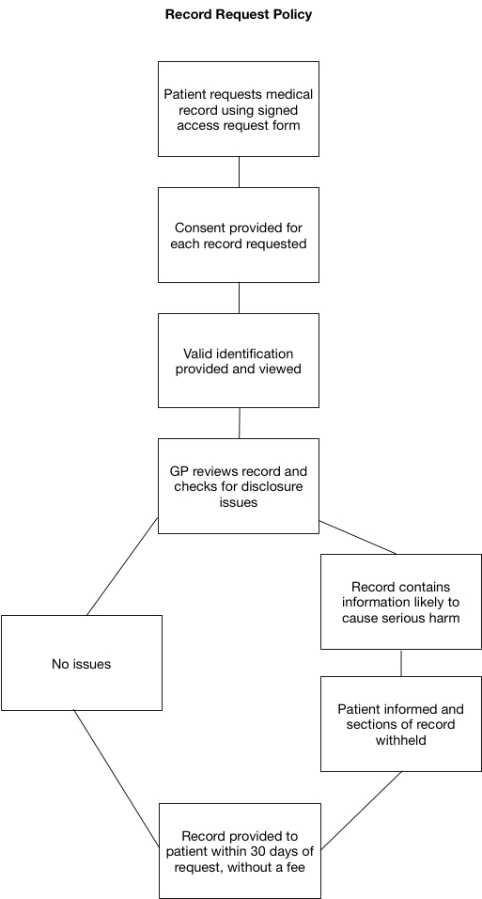

Appendix K: Protocol for Managing a Data Breach
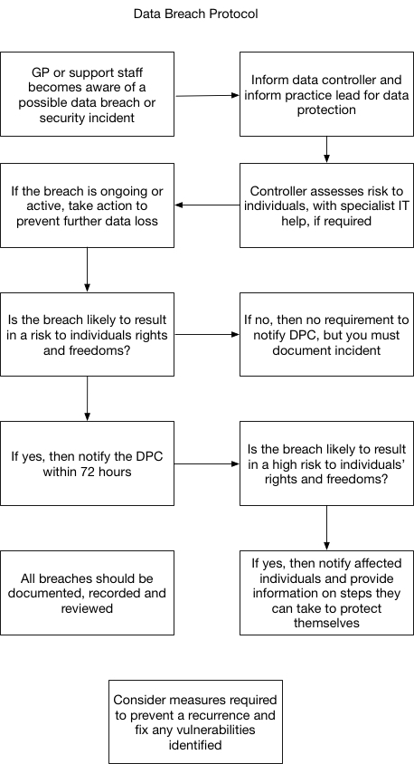

Appendix L: Data Breach Reporting Template

This template may be used as a recording tool in conjunction with the Protocol for Managing a Data Breach

Breach | Response
Summary of the event and circumstances in which it occurred | When, What, Who?
Type and amount of personal data involved | Nature of documents. What sensitive information did they contain?
Have the Data Controller and Data Protection Lead been informed? | Who and when?
Is breach ongoing?  If so, is immediate further action required? | Was this an isolated incident?  Has data been retrieved or destroyed?  Do other parties need to be informed/involved?
Is breach likely to result in a risk to individual rights or freedoms? | Yes/No. Why?
Is it necessary to inform the Data Protection Commissioner within 72 hours? | Notify DPC if answer Yes to question above
Has the affected Data Subject been notified? | What advice has been given to them?
What lessons have been learnt to prevent a recurrence?
What specific actions have been taken?

Reviewed by:

Date:

Appendix M: PCRS Circular 027/18 on Use and Retention of PPSN

